

**MATHEMATICS DEPARTMENT**

**MATHEMATICAL METHODS YEAR 12 – TEST 2**

DATE: 2nd March 2016 Name:_________________________

**Reading Time:** 3 minutes

**SECTION ONE: CALCULATOR FREE**

WORKING TIME: Maximum 30 minutes

TOTAL: 31 marks

EQUIPMENT: pens, pencils, pencil sharpener, highlighter, eraser, ruler, SCSA formula sheet (provided)

**SECTION TWO: CALCULATOR ASSUMED**

WORKING TIME: Minimum 20 minutes

TOTAL: 19 marks

EQUIPMENT: pens, pencils, pencil sharpener, highlighter, eraser, ruler, drawing instruments, templates, up to 3 calculators, formula sheet (provided), one A4 page of notes (one side only)

|  |  |  |  |  |  |
| --- | --- | --- | --- | --- | --- |
| **Question** | **Marks available** | **Marks awarded** | **Question** | **Marks available** | **Marks awarded** |
| 1 | 19 |  | 4 | 7 |  |
| 2 | 6 |  | 5 | 6 |  |
| 3 | 6 |  | 6 | 6 |  |
|  |  |  |  |  |  |
| **Sect 1 Total** | **31** |  | **Sect 2 Total** | **19** |  |
|  |  |  | **TOTAL** | **50** |  |

**Question 1 (19 marks)**

(a) Determine the following, writing your answers with positive indices and simplifying where possible.

(i)  if  (2 marks)

(ii)  (2 marks)

(iii)  (3 marks)

*Question 1 continued on next page …*

**Question 1 continued …**

(iv)  if  (2 marks)

(b) (i) Determine  (2 marks)

(ii) Evaluate exactly  (4 marks)

**Question 1 continued …**

(iii) Evaluate exactly  (4 marks)

**Question 2 (6 marks)**

Consider the following function, , with *x*-intercepts at -3, -1, 2 and 5.

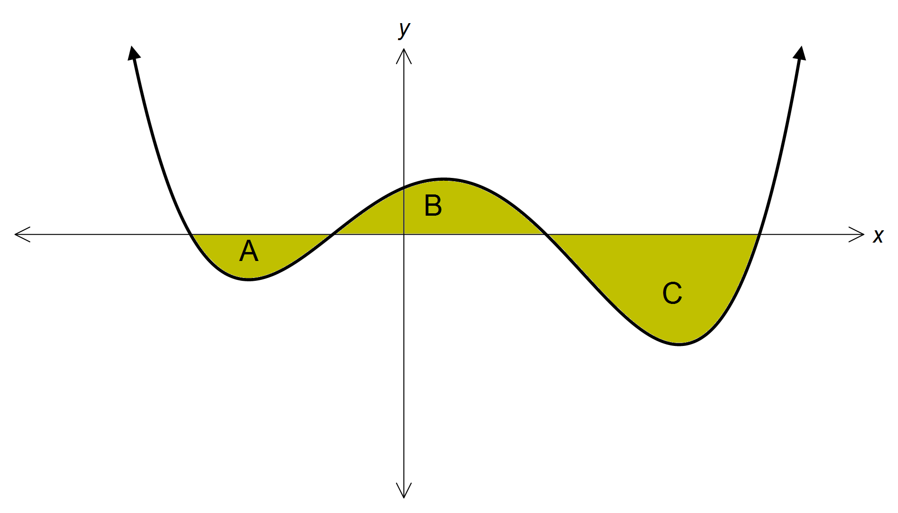

The area of A is 3 cm2, B is 6 cm2 and C is 10 cm2.

Use the graph above to determine the following definite integrals.

(a)  (1 mark)

(b)  (1 mark)

(c)  (1 mark)

(d)  (2 marks)

(e)  (1 mark)

**Question 3 (6 marks)**

A curve has equation . Show that , giving the values of ,  and . Sketch the graph on the axes below. Clearly show the exact location of any turning points, intercepts and asymptotes.

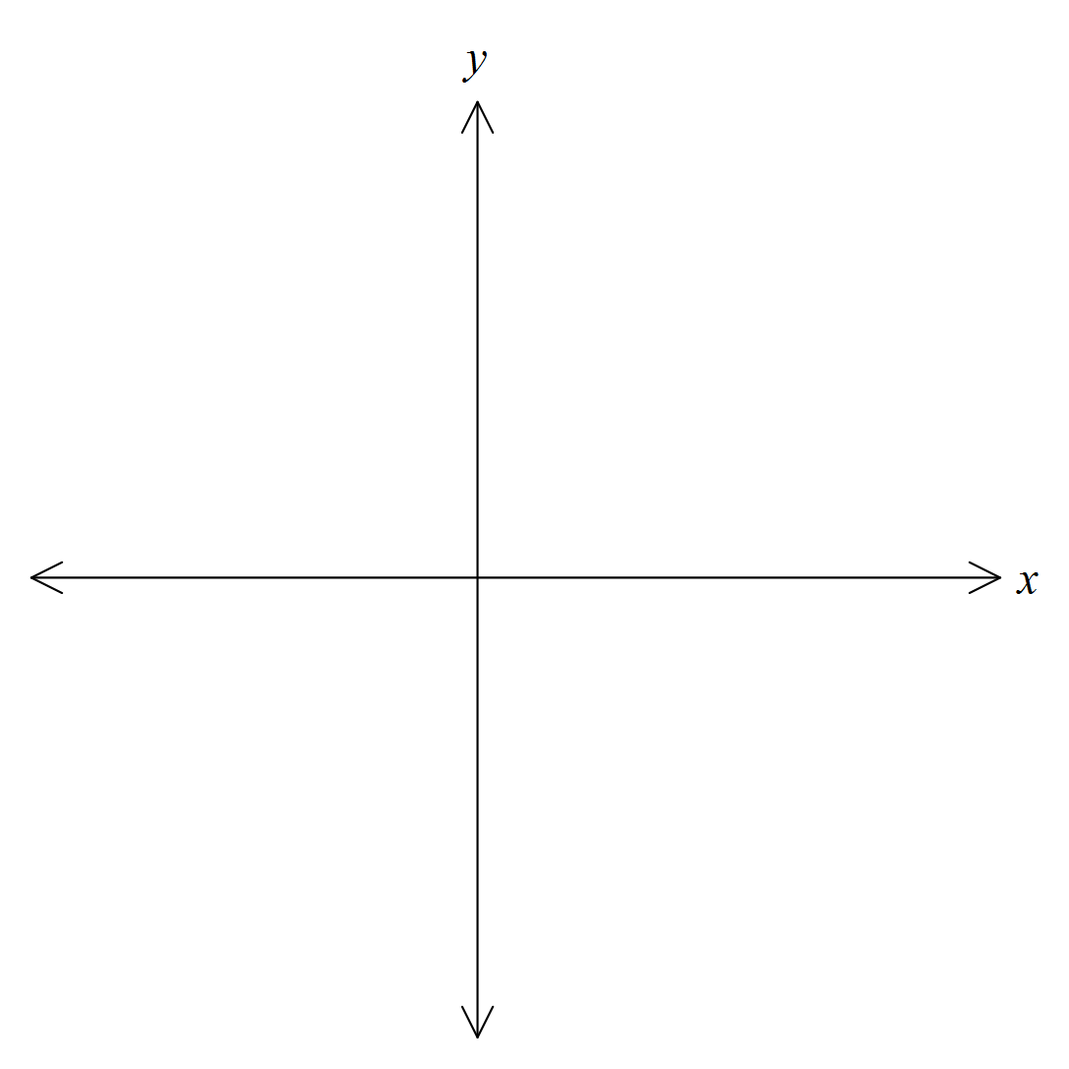

**End of Section 1**

**Section 2: Calculator Assumed Name: ________________________**

**Question 4 (7 marks)**

Students at the University of Sydney observed the number of possums in a nearby area of bushland. It was known that the original population when they commenced observation in January 2010 was approximately 250. The population of possums was found to be growing such that .

(a) Write an equation that can be used to determine the number of possums, t years after the initial observations by the students. (2 marks)

(b) Determine the population of possums in July 2015. (2 marks)

(c) Determine, to the nearest month, when the number of possums will first exceed 400. (3 marks)

**Question 5 (6 marks)**

The amount of current in a circuit,  amps, decreases in accordance with the rule  where *t* is the time in seconds, provided that seconds. It is known that when , the current is 150 amps.

(a) Determine a formula for the current at any time, seconds. (2 marks)

(b) Find the current after 20 seconds (1 mark)

(c) Determine the amount of current lost during the fifth second. (2 marks)

(d) Describe what happens to the current as . (1 mark)

**Question 6 (6 marks)**

(a) Find the area bound by the curve  between ,  and the *x*-axis. (3 marks)

(b) The curves  and  intersect at the point A (1, *a*) as shown in the diagram below.

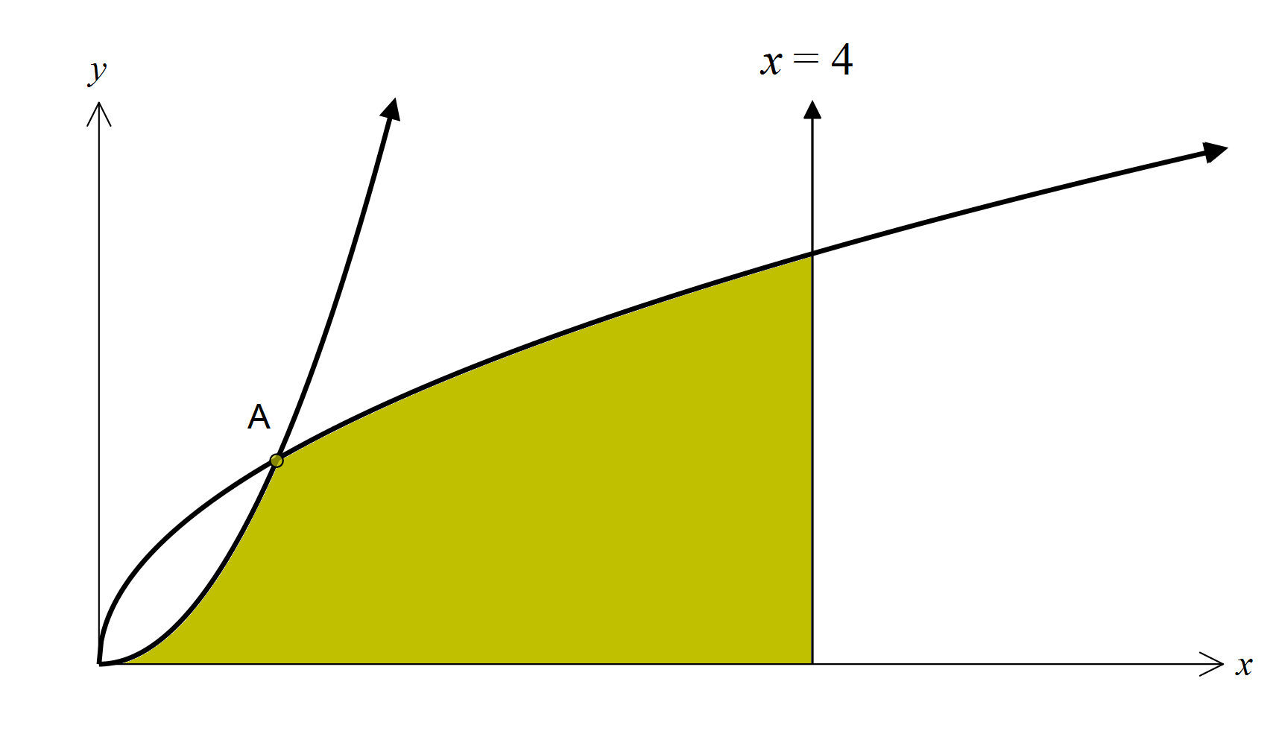

If the shaded area is equal to one square unit, find the value of *a*. (3 marks)

**End of Test**